Data modeling using KNN and Linear Regression

AMAN BHATIA (2338152)
UNIVERSITY CANADA WEST
BUSI 651 Machine Learning
Abby Gholidoust
Date: 8 Aug 2025

Introduction
The following data set house. CVS provides housing market data for 20640 houses from California and includes following features like median household income, population, total rooms, median house age, and proximity to the ocean, with the target variable being median house value.
The goal of my research is: -
- Develop and check accuracy of linear regression model
- Tune its hyperparameters and compare the difference
- Develop a KNN model
- Find how changing K affects overall performance
- Predict house price using both models and make a comparison
- Discuss limitation and advantages of both the models

- Developing a linear regression model
- Dropping missing values.
- Select relevant field median_income,population,total_rooms,housing_median_age.
- Splitting data into 80:20 80% for training and 20% for testing set
- Training linear regression model using scikit learn.
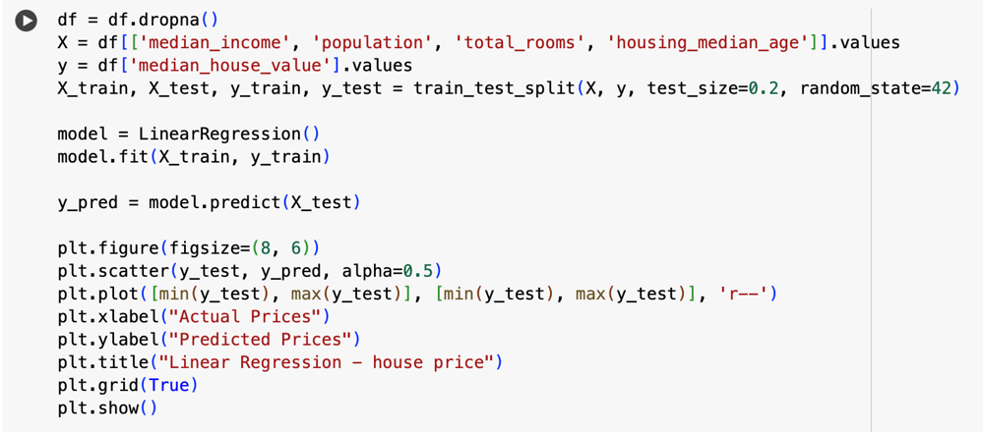
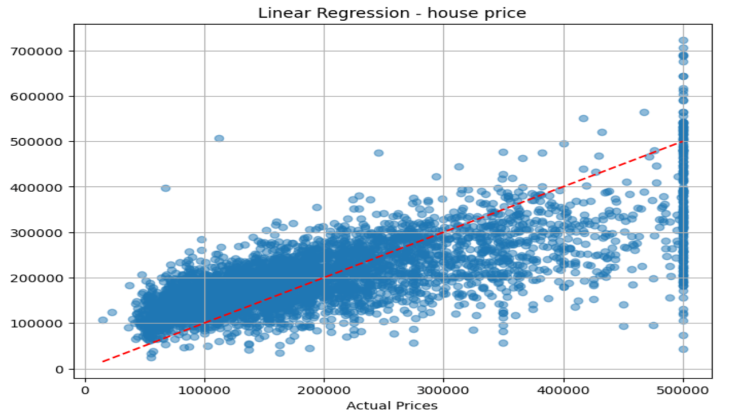

Results for linear regression
Metric | Value
Mean Squared Error (MSE) | 6.60 × 10⁹
Root Mean Squared Error (RMSE) | 81,256
Mean Absolute Error (MAE) | 60,866
R² Score | 0.5172
Explained Variance Score | 0.5172

Interpretation
The R² value is 0.5172 which shows that our model is able to explain 51.7% variance in the house prices. High RMSE tells us that some variability is not captured – likely because of non – linear relationship and omitted variable.

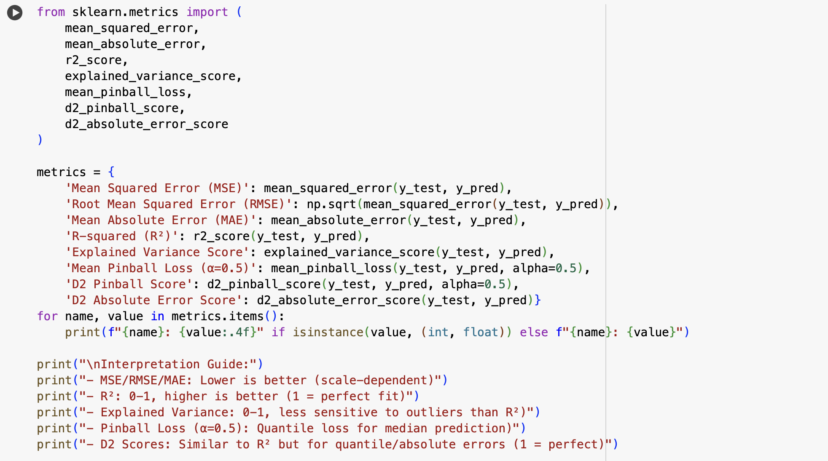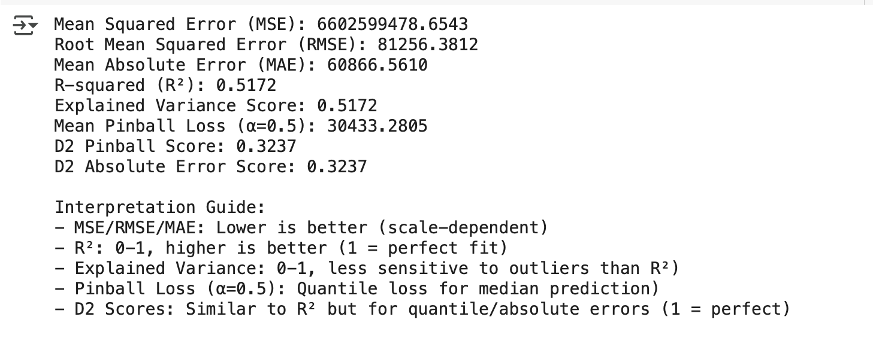

- Hyperparameter tuning

- Method – using gridsearchCV to tune the fit_intercept parameter
- Testing Ridge and Lasso regularization with a = 0.01, 0.1, 1, 10.

Result
- Best parameters : Fit_intercept= True
- Affect = N0 change in R² showing data set is well centred.
- Ridge & Lasso: less changes in output; suggesting less multicollinearity and stable coefficients.

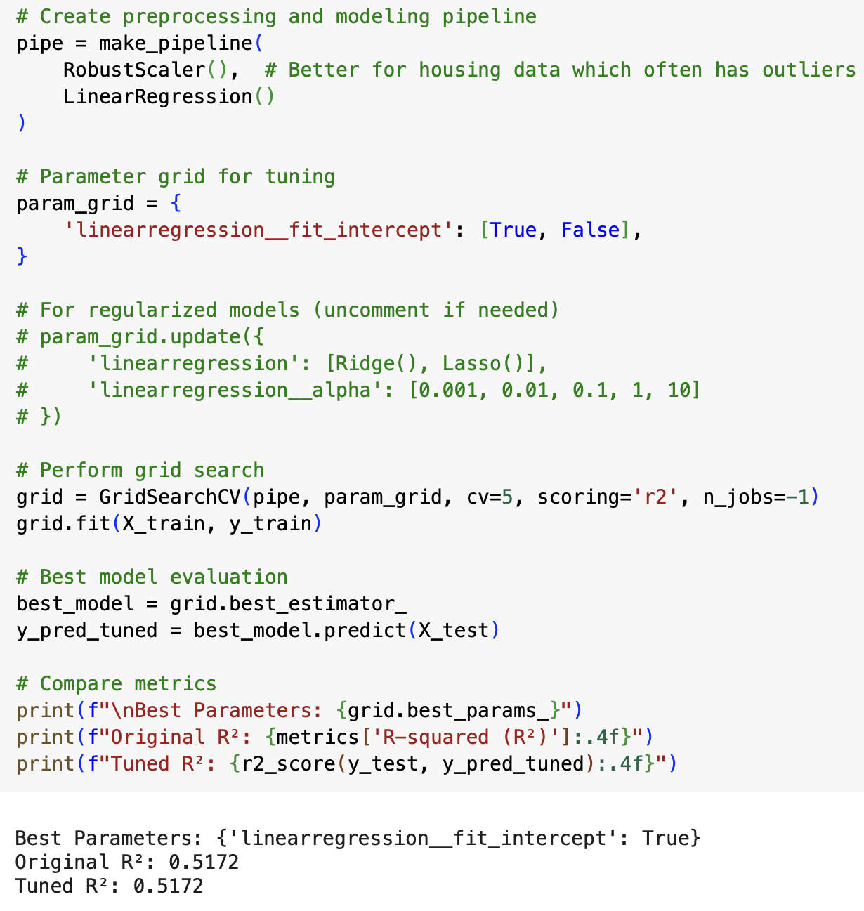

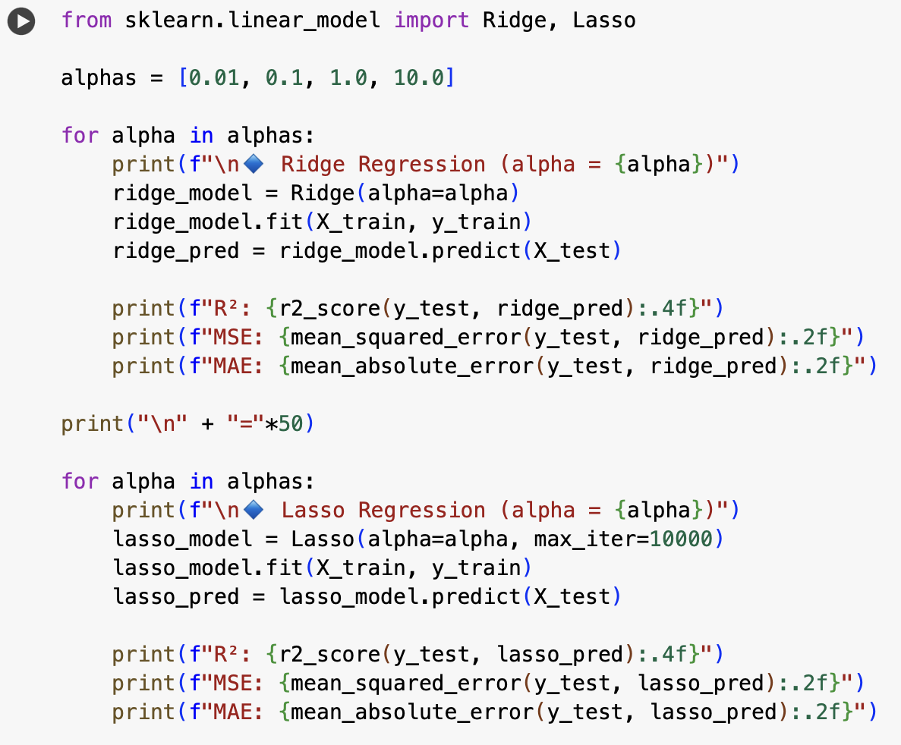

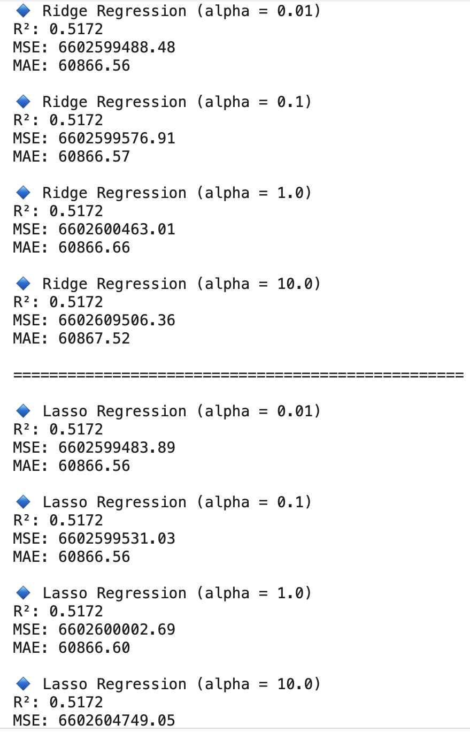

- Developing KNN regression model

Method used
- Tested K from 1 to 20
- Recorded MSE and R² for each K

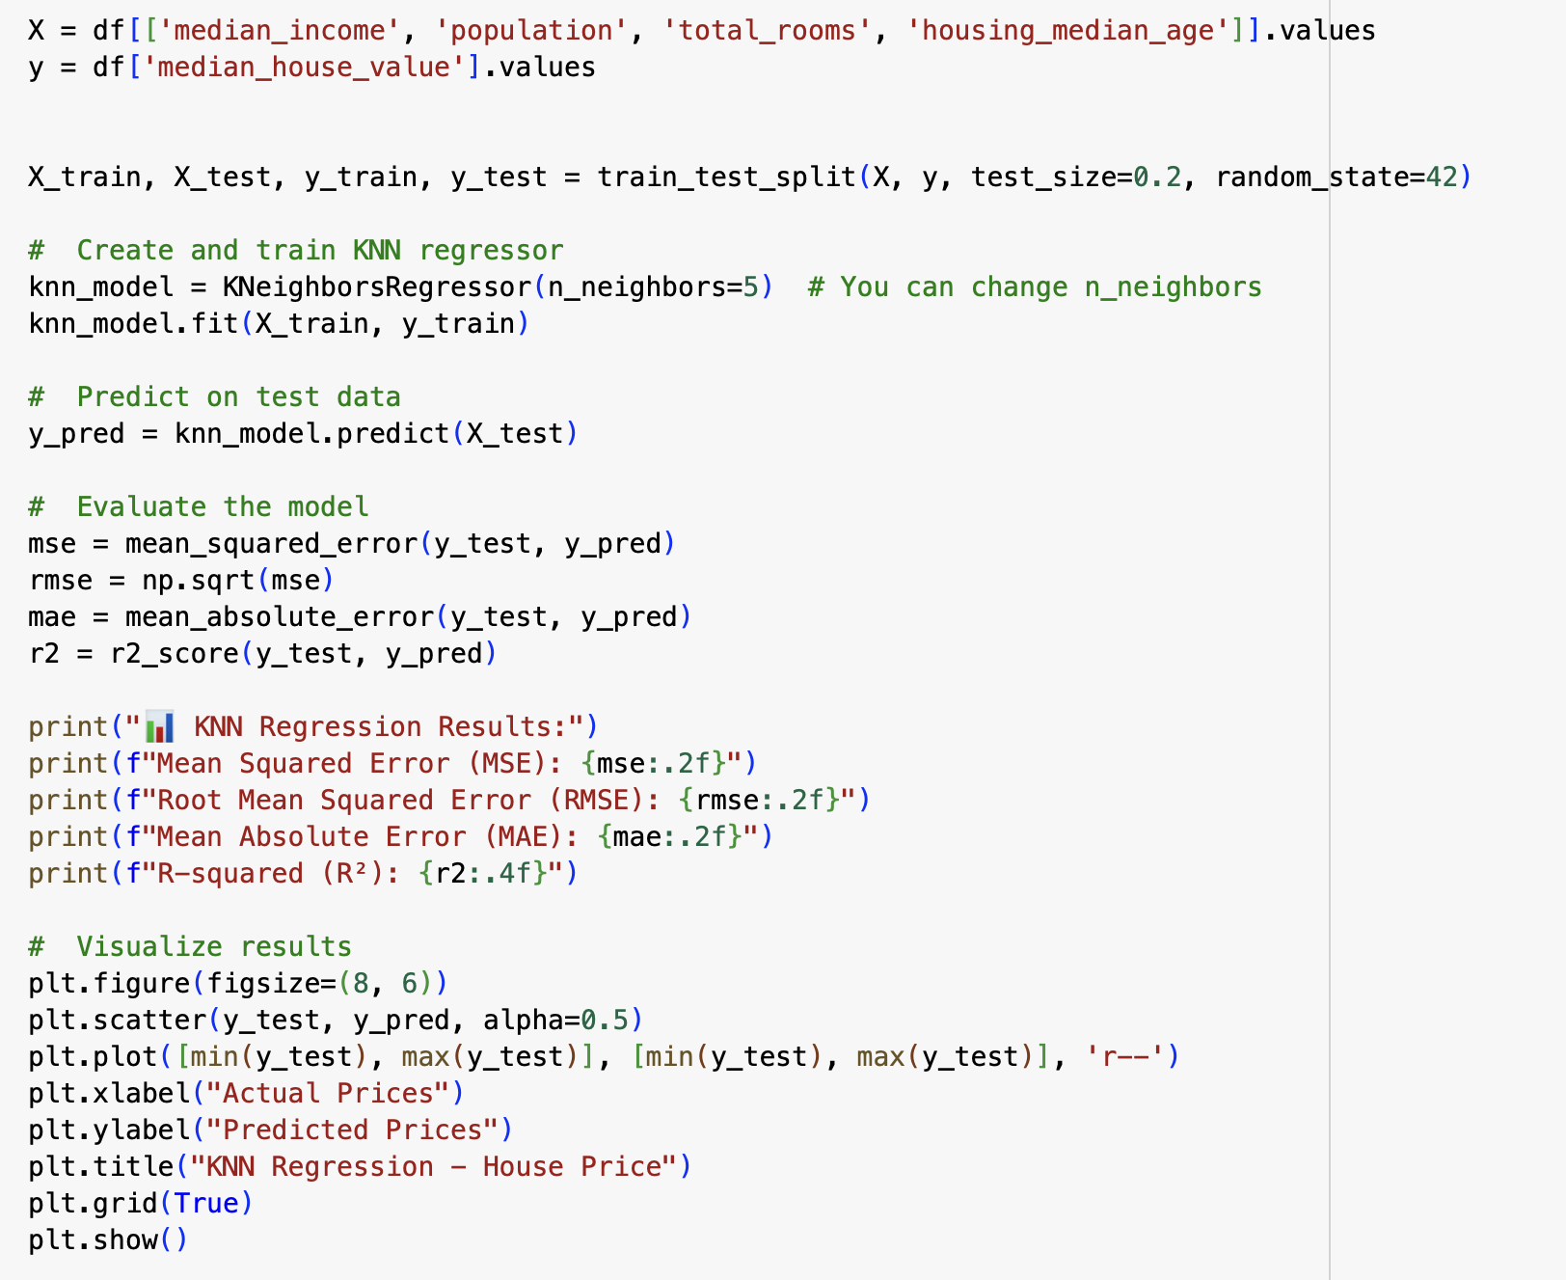

Results

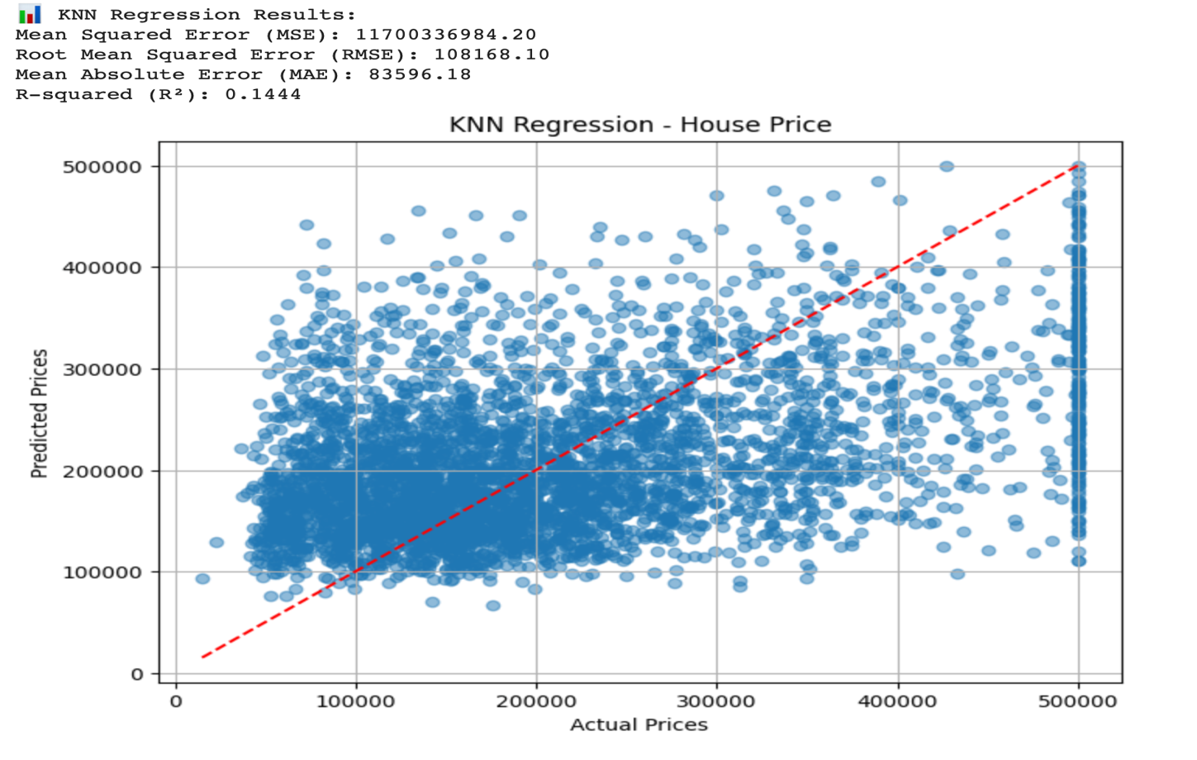

Interpretation
KNN performed slightly worse than Linear Regression in R² and RMSE, suggesting that local averaging may not capture global price trends as effectively.

- KNN Hyperparameter Simulation

Method
- Tested k from 1 to 20.
- Recorded MSE and R² for each k.

Results
- Include MSE vs k and R² vs k line plots.
- Observations:
  - Low k → High variance (overfitting).
  - High k → High bias (underfitting).
  - Best range: k ≈ [Your range].

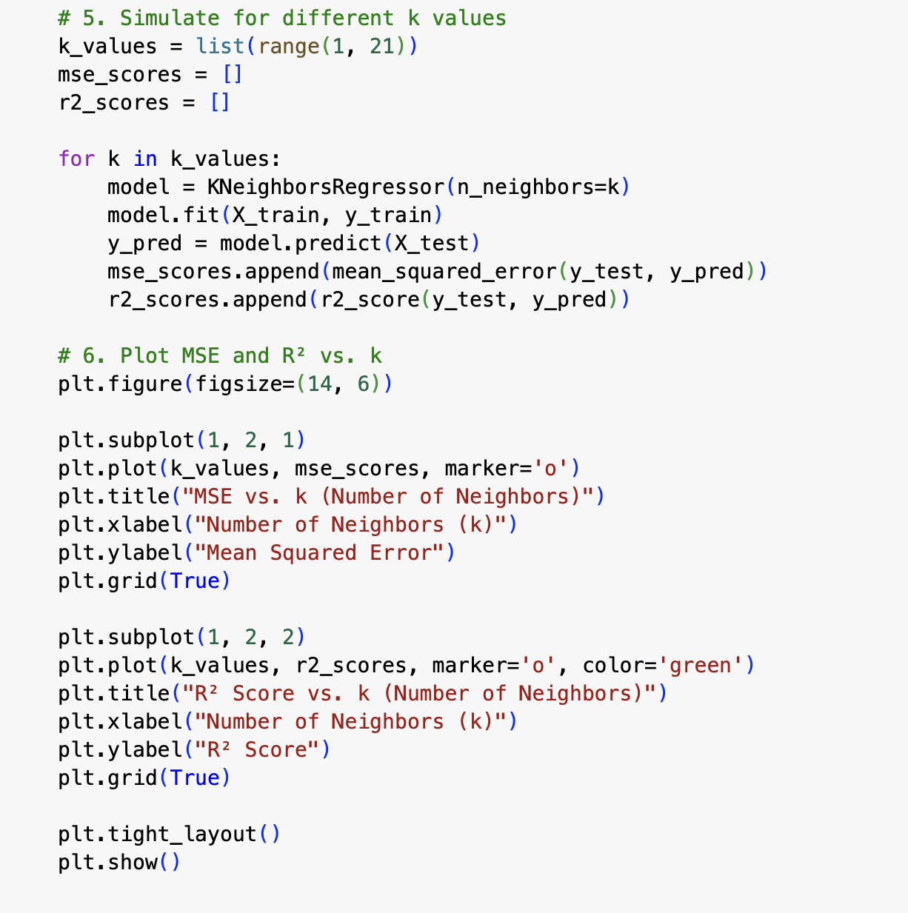
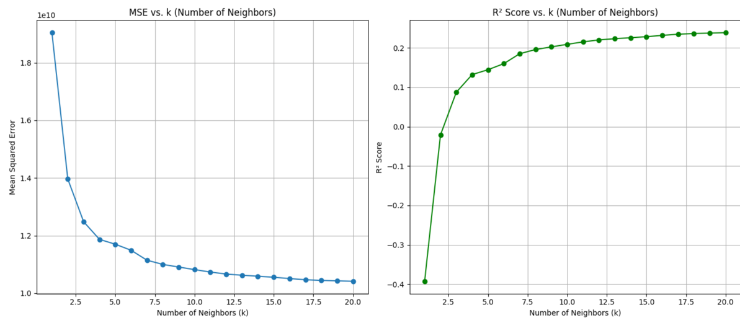

Prediction for Given Input
Given:
- Median Income = 15.8 ($100,000)
- Population = 232
- Total Rooms = 6
- Housing Median Age = 2
Model | Predicted Price
Linear Regression | $636,293.16
KNN (k=5) | $470,000.80
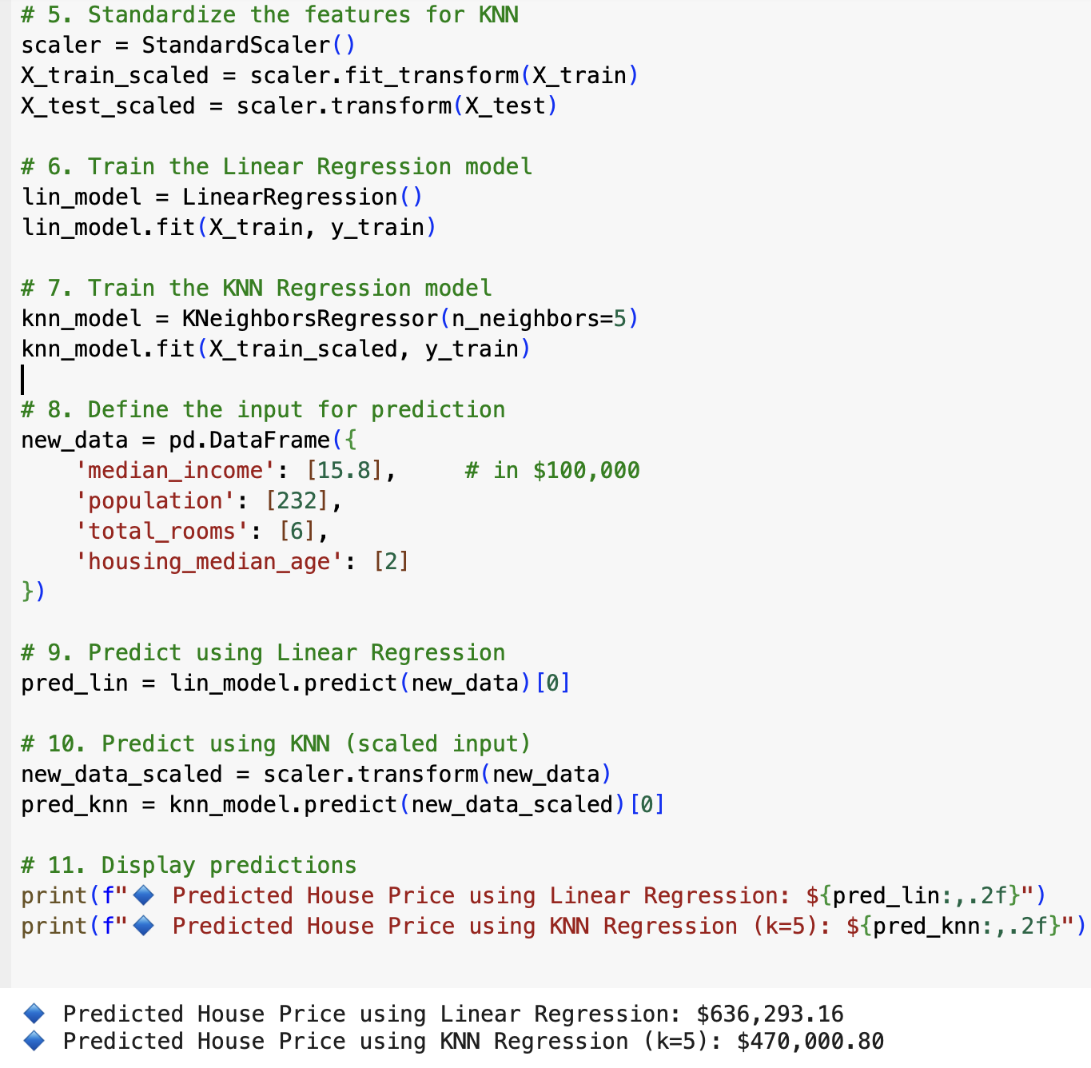

Linear regression extrapolates and considers global trends and hence higher estimate.
KNN makes prediction on similar house in data set hence lower and more realistic.

- Assumptions and Limitations

linear regression assumptions
- Linearity – Predictors have a linear relationship with target.
- Independence of errors – Residuals are independent.
- Homoscedasticity – Equal variance of errors.
- Normality of residuals – Errors have a normal distribution.
- No multicollinearity – Predictors are not highly correlated.
KNN Limitation
- Scaling sensitive and irrelevant features
- In high dimensional spaces performance degrades
- Bias – variance is a tradeoff depending on choice of K
- All the data should be stored in the memory

Conclusion
Both KNN and linear regression provide important insight into housing prices. While linear regression is simple but it is limited to same linear patterns and ignores other important factors that may affect house price on the other hand KNN captures local variance but depends heavily on data density and scaling. To make an improved model we require more features in the housing data set (e.g., proximity to ocean).

References
Pedregosa, F., Varoquaux, G., Gramfort, A., Michel, V., Thirion, B., Grisel, O., … Duchesnay, É. (2011). Scikit-learn: Machine learning in Python. Journal of Machine Learning Research, 12, 2825–2830.
Scikit-learn Developers. (2024). LinearRegression. https://scikit-learn.org/stable/modules/generated/sklearn.linear_model.LinearRegression.html
Scikit-learn Developers. (2024). KNeighborsRegressor. https://scikit-learn.org/stable/modules/generated/sklearn.neighbors.KNeighborsRegressor.html
Week 2: Regression and KNN models BUSI 651 – Machine Learning., university Canada west

IPYNB code
https://colab.research.google.com/drive/1l0RRnK6O_v6B5EluQ-ysQbDkhJTKFVsv?usp=sharing

